**MICROSOFT GRAPH HISTORICAL LOAD TESTING DOCUMENT**

**Table Name: INTUNE_DATA**

Response Keys Matching?: Yes

Response Values Matching?: Yes

**Response from Snowflake:**

{

"activationLockBypassCode": null,

"androidSecurityPatchLevel": "",

"azureADDeviceId": "91c2ed26-4e55-41d6-950d-6e3a8d1eab26",

"azureADRegistered": true,

"complianceGracePeriodExpirationDateTime": "2025-01-09T16:11:30Z",

"complianceState": "noncompliant",

"configurationManagerClientEnabledFeatures": null,

"deviceActionResults": [],

"deviceCategoryDisplayName": "Unknown",

"deviceEnrollmentType": "userEnrollment",

"deviceHealthAttestationState": null,

"deviceName": "Visishta’s MacBook Pro",

"deviceRegistrationState": "registered",

"easActivated": true,

"easActivationDateTime": "0001-01-01T00:00:00Z",

"easDeviceId": "ApplKWR6Q0W4QM",

"emailAddress": "visishta@panteracapital.com",

"enrolledDateTime": "2024-02-26T21:07:16Z",

"enrollmentProfileName": null,

"ethernetMacAddress": null,

"exchangeAccessState": "none",

"exchangeAccessStateReason": "none",

"exchangeLastSuccessfulSyncDateTime": "0001-01-01T00:00:00Z",

"freeStorageSpaceInBytes": 33285996544,

"iccid": null,

"id": "02b12908-c52d-4263-af89-fb6268c0ebbb",

"imei": "",

"isEncrypted": true,

"isSupervised": true,

"jailBroken": "Unknown",

"lastSyncDateTime": "2024-12-13T18:22:32Z",

"managedDeviceName": "visishta_MacOS_2/26/2024_9:07 PM",

"managedDeviceOwnerType": "personal",

"managementAgent": "mdm",

"managementCertificateExpirationDate": "2025-02-23T19:02:06Z",

"manufacturer": "Apple",

"meid": "",

"model": "MacBook Pro",

"notes": null,

"operatingSystem": "macOS",

"osVersion": "14.4.1 (23E224)",

"partnerReportedThreatState": "unknown",

"phoneNumber": "",

"physicalMemoryInBytes": 0,

"remoteAssistanceSessionErrorDetails": null,

"remoteAssistanceSessionUrl": null,

"requireUserEnrollmentApproval": true,

"serialNumber": "KWR6Q0W4QM",

"subscriberCarrier": "",

"totalStorageSpaceInBytes": 530428461056,

"udid": null,

"userDisplayName": "Visishta Dingari",

"userId": "f0baa95b-556a-4acd-b735-7f8899f7692e",

"userPrincipalName": "visishta@panteracapital.com",

"wiFiMacAddress": "bcd074813868"

}

**Response from Postman:**

{

"id": "02b12908-c52d-4263-af89-fb6268c0ebbb",

"userId": "f0baa95b-556a-4acd-b735-7f8899f7692e",

"deviceName": "Visishta’s MacBook Pro",

"managedDeviceOwnerType": "personal",

"enrolledDateTime": "2024-02-26T21:07:16Z",

"lastSyncDateTime": "2024-12-13T18:22:32Z",

"operatingSystem": "macOS",

"complianceState": "noncompliant",

"jailBroken": "Unknown",

"managementAgent": "mdm",

"osVersion": "14.4.1 (23E224)",

"easActivated": true,

"easDeviceId": "ApplKWR6Q0W4QM",

"easActivationDateTime": "0001-01-01T00:00:00Z",

"azureADRegistered": true,

"deviceEnrollmentType": "userEnrollment",

"activationLockBypassCode": null,

"emailAddress": "visishta@panteracapital.com",

"azureADDeviceId": "91c2ed26-4e55-41d6-950d-6e3a8d1eab26",

"deviceRegistrationState": "registered",

"deviceCategoryDisplayName": "Unknown",

"isSupervised": true,

"exchangeLastSuccessfulSyncDateTime": "0001-01-01T00:00:00Z",

"exchangeAccessState": "none",

"exchangeAccessStateReason": "none",

"remoteAssistanceSessionUrl": null,

"remoteAssistanceSessionErrorDetails": null,

"isEncrypted": true,

"userPrincipalName": "visishta@panteracapital.com",

"model": "MacBook Pro",

"manufacturer": "Apple",

"imei": "",

"complianceGracePeriodExpirationDateTime": "2025-01-09T16:11:30Z",

"serialNumber": "KWR6Q0W4QM",

"phoneNumber": "",

"androidSecurityPatchLevel": "",

"userDisplayName": "Visishta Dingari",

"configurationManagerClientEnabledFeatures": null,

"wiFiMacAddress": "bcd074813868",

"deviceHealthAttestationState": null,

"subscriberCarrier": "",

"meid": "",

"totalStorageSpaceInBytes": 530428461056,

"freeStorageSpaceInBytes": 33285996544,

"managedDeviceName": "visishta_MacOS_2/26/2024_9:07 PM",

"partnerReportedThreatState": "unknown",

"requireUserEnrollmentApproval": true,

"managementCertificateExpirationDate": "2025-02-23T19:02:06Z",

"iccid": null,

"udid": null,

"notes": null,

"ethernetMacAddress": null,

"physicalMemoryInBytes": 0,

"enrollmentProfileName": null,

"deviceActionResults": []

}

**Table Name: EMPLOYEE_DATA**

Response Keys Matching?: Yes

Response Values Matching?: Yes

**Response from Snowflake:**

{

"accountEnabled": true,

"department": "Platform",

"displayName": "Franklin Bi",

"employeeHireDate": "2019-05-06T12:00:00Z",

"employeeType": "Salaried, full-time",

"givenName": "Franklin",

"id": "ca289a9c-da1f-41a6-8c00-68bb712fb541",

"officeLocation": "San Francisco",

"surname": "Bi",

"userPrincipalName": "franklin@panteracapital.com"

}

**Response from Postman:**

{

"accountEnabled": true,

"department": "Platform",

"displayName": "Franklin Bi",

"employeeHireDate": "2019-05-06T12:00:00Z",

"employeeType": "Salaried, full-time",

"givenName": "Franklin",

"id": "ca289a9c-da1f-41a6-8c00-68bb712fb541",

"officeLocation": "San Francisco",

"surname": "Bi",

"userPrincipalName": "franklin@panteracapital.com"

}

**Table Name: EMAIL_DATA**

Response Keys Matching?: Yes

Response Values Matching?: Yes

**Response from Snowflake:**

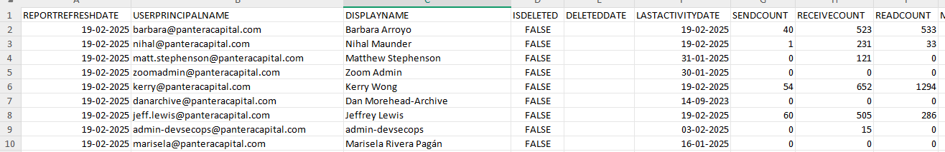

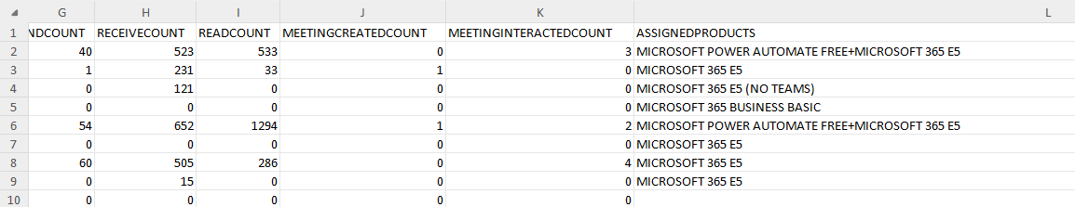

**Response from Postman:**

